**HITEC University Taxila**

**Department of Computer Engineering**

**EC-230 Object Oriented Programming Lab Project Report**



**Submitted by:**

|  |  |
| --- | --- |
| **Abdullah Javed** | **20-CE-035** |
| **Fatima Asim** | **20-CE-029** |

**Submitted to:**

**Lab Instructor Kaynat Rana**

**1 |** P a g e

**The Common Application**

**Introduction:**

The Common Application is an undergraduate college admission application that students may use to apply for admissions in various universities across the country. Its purpose is to make the admission application process simple and easy for the applicants.

This application is used for applying for admissions in universities online. As we may have experienced, while applying for admission in our preferred institutions, we have to repeat the same process of registering for an account, providing our bio data, and uploading our documents over and over again on different websites, which is a time taking and frustrating process. The common application simply required one-time registration, and one-time form filling. By matching the eligibility criteria of the universities selected by the applicant and the applicant’s data, the app is capable of filtering out the universities in which the applicant is eligible for admission, and automatically applies for admission in those universities.

**OOP:**

The source code contains the following OOP Concepts:

* Class
* Objects
* Encapsulation
* File Handling
* User Defined Functions
* Data Hiding
* Control Structures

**Modules:**

Following are the major functions in the software:

* void login()
* void reg()
* void fp()
* int set_file()
* int edit_file()
* int get_file()
* void menu_2()
* void set_data()
* void get_data()
* void edit_data()
* int ec()

**Class Diagram:**

|  |
| --- |
| **Data** |
| * fname : char |
| * lname : char |
| * father_name : char |
| * cnic : int |
| * province : char |
| * city : char |
| * address : char |
| * email : char |
| * program : char |
| * age : int |
| * ssc_dis : char |
| * hssc_dis : char |
| * ssc_marks : int |
| * hssc_marks : int |
| * contact : int |
|  |
| + Data () |
| + set_data () : void |
| + get_data () : void |
| + edit_data() : void |

**Main Menu:**

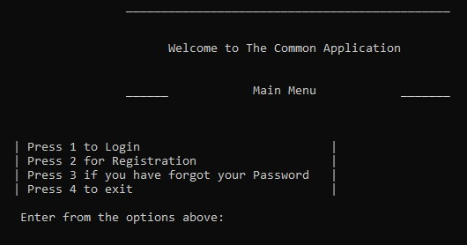

This is the main menu of the application. Here the user can login, register for an account, or recover an account’s password.

**Login:**

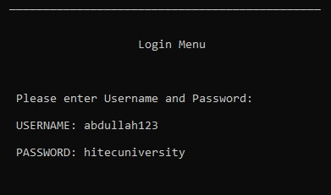

Here, user simply enters his/her user name and password if he/she already has an account.

**Registration:**

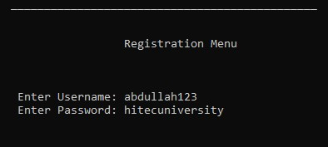

In this menu, the user creates a new account for using the application.

**Forgot Password:**

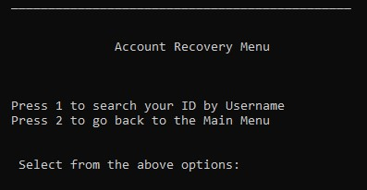

The account recovery menu gives the option to recover the password of an account by entering the username.

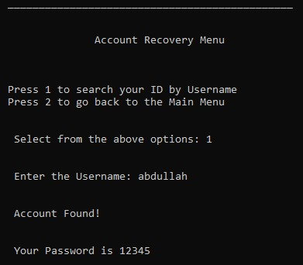

**Account Menu:**

Upon logging into the account, the following are the functions provided to the user by the application.

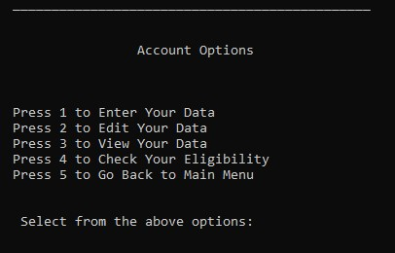

**Set Data:**

This is a one-time form filling menu, the user will have to enter the details only once.

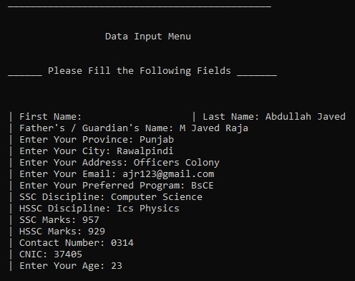

**Edit Data:**

This menu enables the user to edit data in case the user has made a mistake during form filling

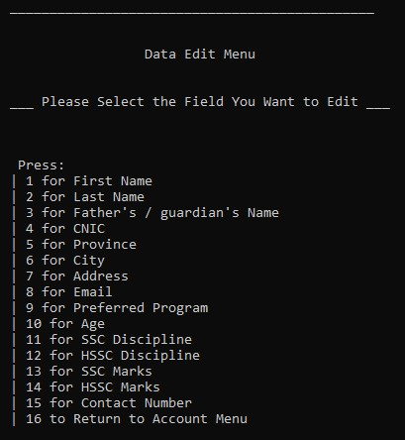

**Check Eligibility:**

The user can check whether or not he/she is eligible for admission or not

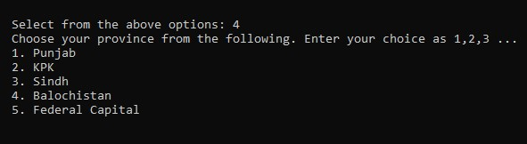

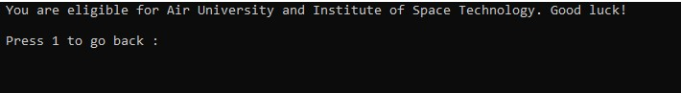

**Conclusion:**

The Common Application is an easy way to apply for admissions in the universities across the country. It saves the user’s time and prevents the user from entering the same data over and over again. We have made this application by keeping in mind the needs of the modern-day students. We have applied the concepts of Object Oriented Programming and we have developed this software using C++ Language. We have implemented all the techniques of OOP which we have learned throughout this semester.